Uniforms pt.2 –
- Alternative Unisex Weathered Tee, AA6094, $11.90 (image 1)
  - Good value, contemporary cut, offer white, black and blue color options.
- Alternative Women’s Backstage Vintage Tee, AA5064, $11.90 (image 2)
  - Good value, contemporary cut, would be specifically for the individuals who prefer this type of cut, offer white, black, and blue color options.
- Bella+Canvas Unisex Triblend Tee, BC3414, $10.28 (image 3)
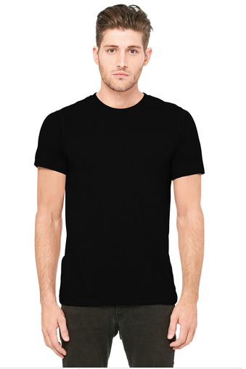
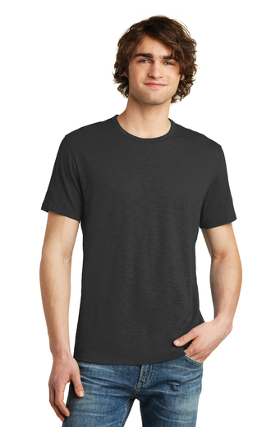
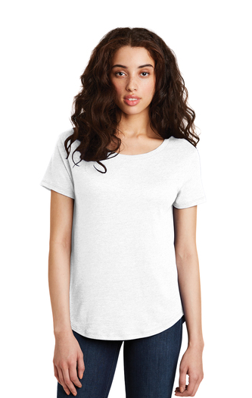
  - Good value, contemporary cut, bit of an intermediary between the two styles above, and comes with excessive amount of color options.

